Jose Solis

17 December 2023

Grocery List Manual

1. When you first open the program you will be greeted with a main menu.
   1. Option 1 is to start creating a list which will move to the list screen
   2. Option 2 is the exit button which will close your application

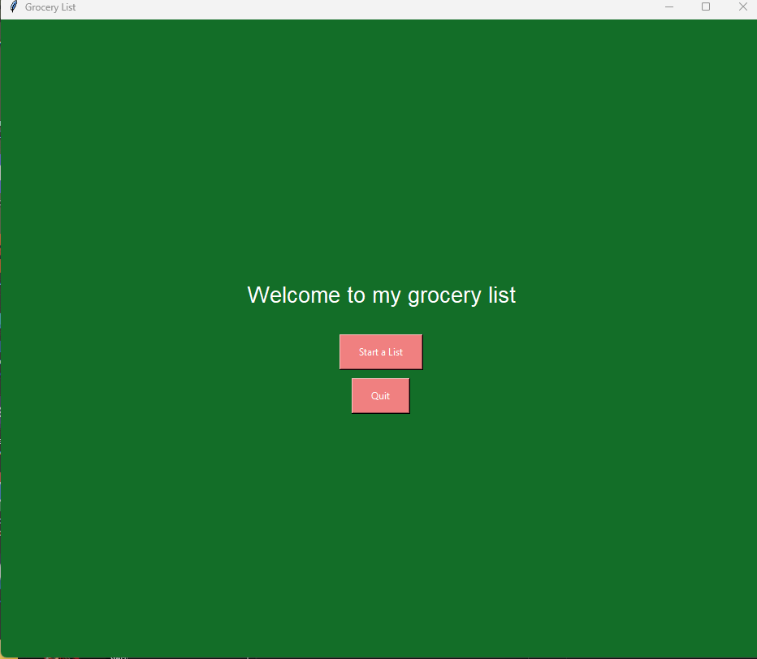

1. When you start a list a couple on text fields will show up, this is where you input list data and manipulate it as well.
   1. Enter Item: insert item name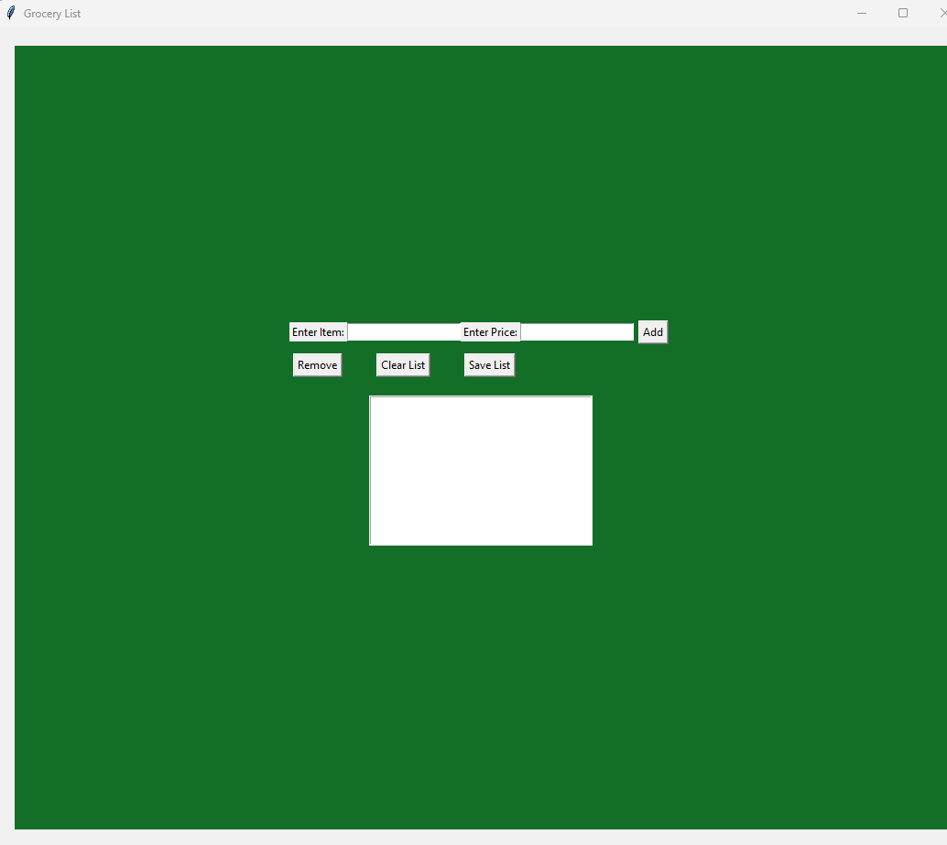
   2. Enter Price: Input item price
   3. Add: Adds item to list
   4. Remove: when selecting an item and clicking remove the item will be taken out of the list.
   5. Clear List: The entire list is deleted
   6. Save List: The list will be saved in a file.